Richmond (Yorks) Golf Club

**Friday 12th November 2021**

**Starts 7:30**

**Horses for sale £5:00**

Contact Amy or Barbara Gregory 07402858599

There will be seven races, six heats and a final

Owners must nominate a jockey for each race

Heat winner receive a small prize and qualify for the final.

In the Final prizes will be :- Winner £50,

Second £20,

Third £10

Betting is in the form of a tote … the value of all the bets will be totalled and paid out equally to those betting on the winning horse.

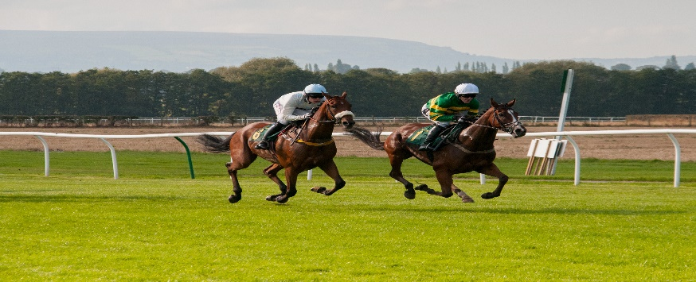

[This Photo](https://www.horseracingphoto.co.uk/portfolio-item/two-horses-racing/) by Unknown Author is licensed under [CC BY](https://creativecommons.org/licenses/by/3.0/)